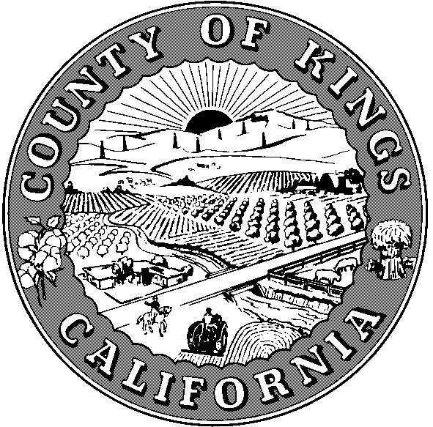
COUNTY OF KINGS
BOARD OF SUPERVISORS
GOVERNMENT CENTER HANFORD, CALIFORNIA 93230 (559) 852- 2362
Catherine Venturella, Clerk of the Board of Supervisors

AGENDA ITEM
December 12, 2023
SUBMITTED BY: | Administration – Kyria Martinez  Clerk of the Board’s Office – Catherine Venturella

SUBJECT: | Board Meeting CANCELLATION Schedule for 2024

SUMMARY:

Overview:
Each year, the County issues a holiday schedule identifying the dates it will be closed for business. The Board has, over the last several years, cancelled Board meetings on the following days: Tuesdays that follow Monday holidays; the first Tuesday in May for the Employee Recognition barbecue; the meetings that coincide with the National Association of Counties (NACo) Legislative Conference; the California State Association of Counties (CSAC) Annual Meeting; and during the week between Christmas and New Years.

Recommendation:
Approve the cancellation schedule for the Board of Supervisors’ meetings for 2024.

Fiscal Impact:
No fiscal impact due to cancellation of meetings.

BACKGROUND:
The Board has recognized holidays each year by issuing a schedule of meeting cancellations in advance, so that staff can plan accordingly and to advise outside agencies whose meetings follow the Board meetings. Staff is recommending a schedule of meetings every Tuesday in 2024 except for the following dates:

January 16, 2024 – Tuesday after Martin Luther King Day
February 13, 2024 - National Association of Counties (NACo) Legislative Conference
February 20, 2024 – Tuesday after President’s Day
May 7, 2024 – Employee Recognition Barbeque
May 28, 2024 – Tuesday after Memorial Day
September 3, 2024 – Tuesday after Labor Day
November 12, 2024 -Tuesday after Veteran’s Day
November 19, 2024 – California State Association of Counties Annual Conference
December 24, 2024 – Tuesday, Christmas Eve
December 31, 2024 – Tuesday, New Year’s Eve

