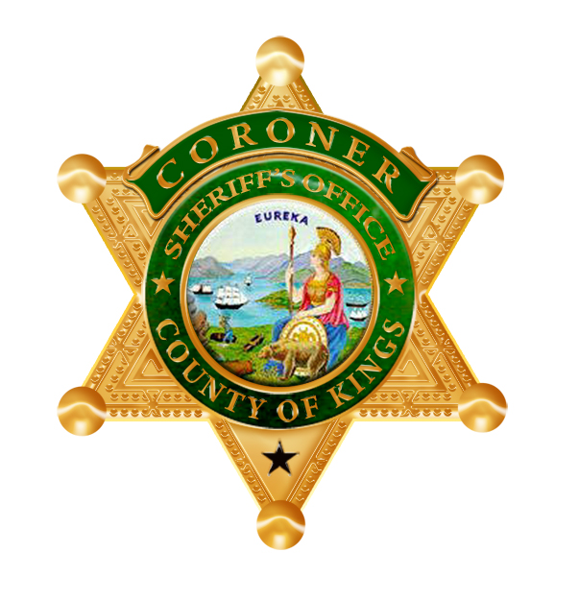 |  |  | OFFICE OF  SHERIFF  COUNTY OF KINGS |  | Coroner/Public Administrator Division  1470 North Drive  Hanford, CA 93230  Phone (559) 852-2874  Fax (559) 584-3103
 | Date:

I certify that, pursuant to Section 7100, Health & Safety Code, State of California, as next of kin, it is my right to select any funeral director I desire to take charge of the decedent’s body
(Decedent Name)
Therefore, please release the body and personal effects of the above-mentioned decedent to

_________________________________________________________________________.
(Funeral Provider, address and phone number)
This is a voluntary action on my part and there has been no solicitation or effort made by any

representative of the above named funeral home or the Kings County Sheriff-Coroner’s Office to

influence me to use said funeral home.
Signature (Next of Kin or Authorized Person)

Full Name (Typed or Printed)
Address
City, State, Zip Code
Telephone Number
Relationship to Deceased

